### Documented By Suresh Revelli

**Document Created on 10-04-2015**

### Learned Topics

**1. How to install centOS through network**

* First boot bios settings as Ethernet, save and exit
* Select basic storage device
* Next enter host-name
* Select city as (kolkata,Asia)
* Enter root password
* Next select custom layout
* Next write change disk
* Next customize now
* Select standard partitions
* Give partitions to /boot,/root and swap(Don't delete NTFS partition)
* Next assign user password details.

**2. How to assign proxy in Linux**

* Go to preferences and select network and type (proxy.iiit.ac.in) and give port no:8080
* Open the browser enter (mail.iiit.ac.in) and copy the address and paste in no proxy.

**3. How to configure network in Ubuntu**

* Open terminal type **sudo su -**
* **gedit /etc/Networkmanager/NetworkManager.conf** and make it as true and save
* **gedit /etc/network/interfaces** (comment (#) auto lo, and iface lo and save.

**4. How to create user in Linux command**

* useradd <username>

passwd <username>

new passwd: retype passwd

**5. How to crimp RJ45**

* white (Orange) Orange
* White (Green) Blue
* White (Blue) Green
* White (Brown) Brown

6**. How to create file**

* touch <filename>

**7. How to view file**

* cat <filename>

**8. How to edit user name**

* usermod -l <new username> <old username> and reboot

**9. Files and Directories**

* **mkdir <dir_name>**#creates specified directories
* r**mdir <dir_name>** #removes empty directories
* **rm <filename>** #removes filename
* **rm -r <dir_name>**#removes directory its content,but asks for configuration.
* **cp <name> <path>** copy files/directory as specified in path
* **mv <name1> <name2>** renames directory files
* **mv <name><path>** moves file/directory as specified path.

**10. Hardware Issues:**

* To check SMPS sort black and green wires, if fan rotates its working,if not its does not work.
* If monitor displays empty screen check RAM, clean it and replace it.
* If power button doesn't work, open the cpu and sort the power sockets.
* If HDD does not work, it don’t display the screen.
* To change BIOS password open the CPU and remove jumper, reset passwords in BIOS and insert jumper and restart system.

**11. How to make Directory in Linux command:**

* mkdir <directory name>
* To rename Directories **:mv <foldername> <foldername>**
* **mkdir -pv** for parent directory
* To delete directory: **-rm -rf <foldername>**
* To check time of the file : **ls -ld**
* To change the time or date of the file : **touch -d “01/1/2015” <file name>**

**12. To change Root Password when Authentication Failure**

* Ctrl+alt+F2 → type root and give root password → and change user password → exit → ctrl+Alt+F1

**13. Vi(virtual Interfaces) Editor basic commands**

* **To open** → vi <filename>
* **:q** → quit without saving
* **:w** → save
* **:wq** → save & quit
* **:wq !** → save & quit forcefully
* **:se nu** → setting line numbers
* **:se nonu** → removing line numbers
* **dd** → Delete a line
* **2dd** → Deletes 2 lines
* **yy** → copy a line
* **2yy** → copies 2 lines
* **yw** → copy single word
* **2yw** → copies 2 words
* **p** → put or paste copied text
* **u** → undo(can undo 1000 times)
* **ctrl+r** → redo
* **G** → Moves cursor to last line of file
* **5G** → Moves cursor to 5th line of file
* **shift+ZZ** →? save & quit
* **/<find word>** → Locate word
* How to replace word→ **1,$s/old word/new word/gc**
* TO LOCK FILE → **:set key=Password**
* TO UNLOCK FILE → **:set key=” “**

**14. To Configure scanner in Ubuntu**

* If HP printer is configured using hp-setup then both printer and scanner get added to the system properly. However if only printer is added using 'system-config-printer' then scanner is not detected while trying to use Scanner Tool (xsane). In such cases scanner can be used as follows:
* First sane URI of printer needs to be formed using → **hp-makeuri <printer-ip>**
* Then start xsane with sane URI as → **xsane <sane-uri>**

**15. How to change grub password**

* grup2-m → grub2 -mkpasswd-pbkdf2
* copy the password → vim /etc/grub.d/40-custom
* set superuser = root
* password root_pbkdf2 PBKDF2

**16. How to install Linux OS through cloning process**

* It is the process which is used to install Linux OS through storing memory into the RAM with system rescue 4.5.2 CD.
* first we have to copy the data into the RAM through System rescue CD in the master system, later copy the same data into other systems.
* later use command in Master system → **udp-sender --file /dev/sda --full-duplex**
* next type another command to receive the data from master → **udp-receiver --file /dev/sda**

**17. How to configure FTP service**

* To check FTP installed or not →**# chkconfig --list | grep vsftpd**
* To install FTP → **# yum -y install vsftpd**
* To check FTP configuration → **# vim /etc/vsftpd/vsftpd.conf**
* **# cd /var/ftp/pub/**
* **# service vsftpd restarts**

**18. How to configure Printer in CentO**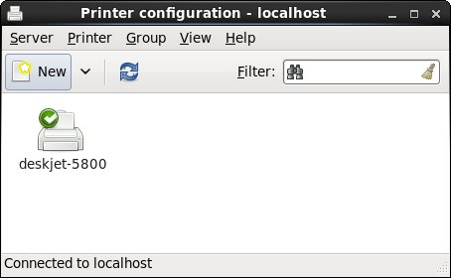

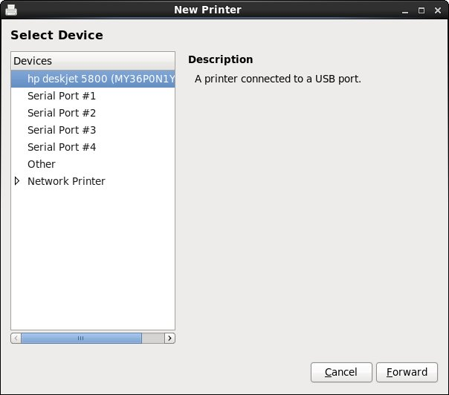

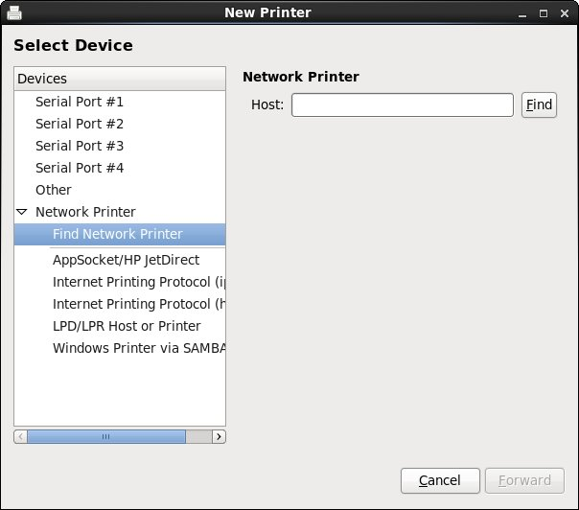

**19. Connecting Network Printers in 10 Simple Steps**

* Go to dash
* Type Printers
* Click on the printer icon
* Click add (+)
* Click "Network Printer"s and select printer (you may have to wait a minute for it to load)
* Click on your Printers title
* Click "Forward"
* Click Select for the Printers Company (choose recommend if you don't know)
* Choose Model (choose recommend if you don't know) 10.Choose the Number of Input Trays
* Choose The Printers Name
* Print Test Page

**20. How to Copy files through SCP**

* scp <file> <username>@<IP address or hostname>:<Destination>

**21. How to Format USB Drive in the Terminal**

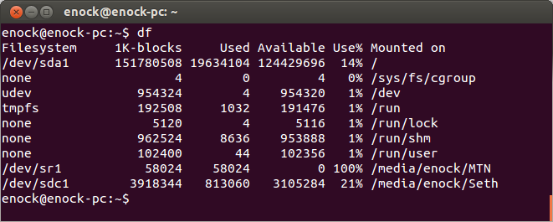In this tutorial, the name of the drive am going to format is **Seth** and its path under the filesystem is **/dev/sdc1**.

3. Unmount drive using the syntax below:

**$ sudo umount /dev/sdc1**

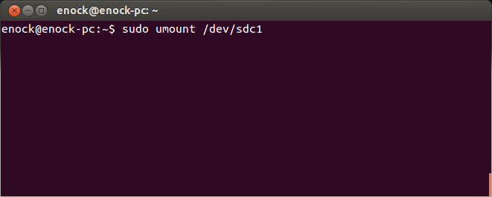4. Now run this command to format drive to **fat32**:

**$ sudo mkfs.vfat -n 'Ubuntu' -I /dev/sdc1**

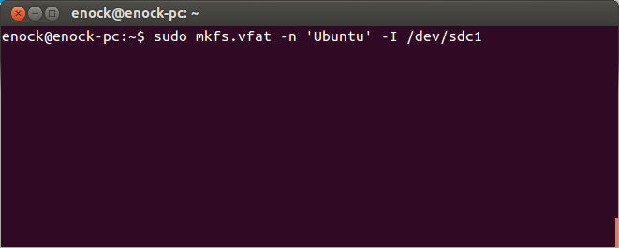

**Understanding the above command**

**mkfs**

mkfs is used to build a Linux filesystem on a device, usually a hard disk partition. The device argument is either the device name (e.g. /dev/hda1, /dev/sdb2), or a regular file that shall contain the filesystem. The size argument is the number of blocks to be used for the filesystem.

**vfat**

Formats the drive to FAT32, other formats available are **mkfs.bfs, mkfs.ext2, mkfs.ext3, mkfs.ext4, mkfs.minix, mkfs.msdos, mkfs.vfat, mkfs.xfs, mkfs.xiafs etc.**

**-n**

**Volume-name** sets the volume name (label) of the file system. The volume name can be up to 11 characters long. The default is no label. In this tutorial my volume-name is **Ubuntu**.

**-I**

It is typical for fixed disk devices to be partitioned so by default, you are not permitted to create a filesystem across the entire device.

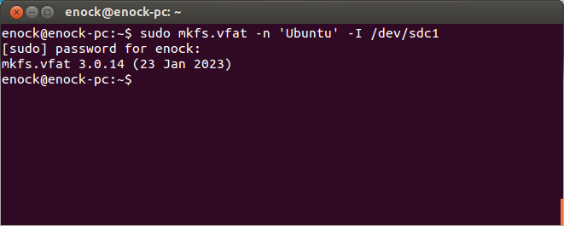Running **$ df** after formatting displays this.

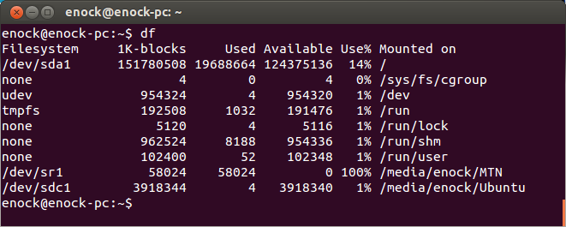

**23**. **How to reset password in ubuntu 14.04**

1. Reboot your computer.
2. Hold Shift during boot to start GRUB menu.
3. Highlight your image and press E to edit.
4. Find the line starting with "linux" and append rw init=/bin/bash at the end of that line.
5. Press Ctrl + X to boot.
6. Type in passwd username.
7. Set your password.

root@ubuntu:~#

At this stage you should have a read-only filesystem. You have to remount it with write permissions:

mount -rw -o remount /

Now we can set the user's password with the passwd command. (In this example I will use jorge as the example, you need to substitute whatever the user's username is):

root@ubuntu:~# passwd jorge  
Enter new UNIX password:  
Retype new UNIX password:  
passwd: password updated successfully  
root@ubuntu:~#

**24. How to reset root password in Fedora-20**

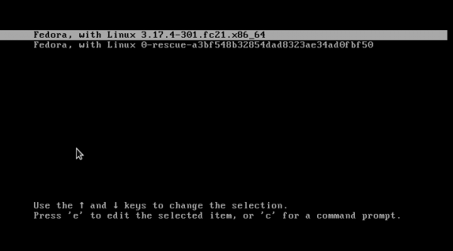

2.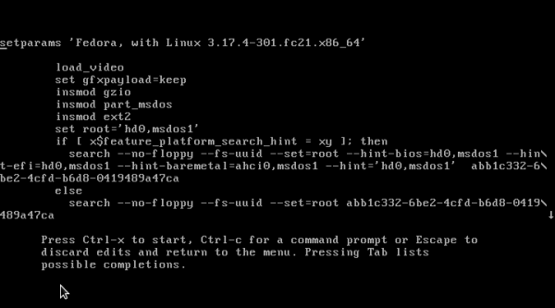

3. 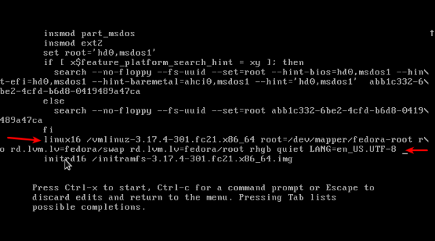

4.

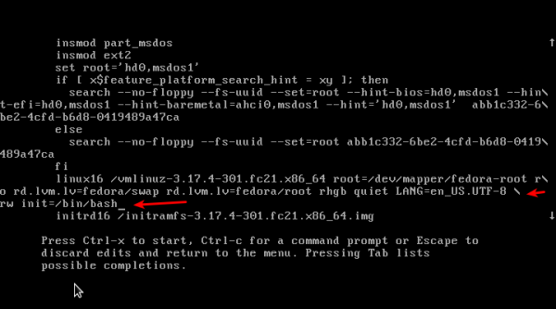

5. 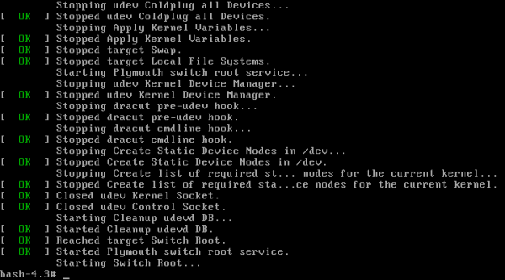

**25. File Permissions**

This lesson will cover the following commands:

* [chmod](http://linuxcommand.org/man_pages/chmod1.html) - modify file access rights
* [su](http://linuxcommand.org/man_pages/su1.html) - temporarily become the superuser
* [chown](http://linuxcommand.org/man_pages/chown1.html) - change file ownership
* [chgrp](http://linuxcommand.org/man_pages/chgrp1.html) - change a file's group ownership

Linux uses the same permissions scheme as Unix. Each file and directory on your system is assigned access rights for the owner of the file, the members of a group of related users, and everybody else. Rights can be assigned to read a file, to write a file, and to execute a file (i.e., run the file as a program).

To see the permission settings for a file, we can use the ls command as follows:

[me@linuxbox me]$ ls -l some_file

-rw-rw-r-- 1 me me 1097374 Sep 26 18:48 some_file

We can determine a lot from examining the results of this command:

* The file "some_file" is owned by user "me"
* User "me" has the right to read and write this file
* The file is owned by the group "me"
* Members of the group "me" can also read and write this file
* Everybody else can read this file

Let's try another example. We will look at the bash program which is located in the /bin directory:

[me@linuxbox me]$ ls -l /bin/bash

-rwxr-xr-x 1 root root 316848 Feb 27 2000 /bin/bash

Here we can see:

* The file "/bin/bash" is owned by user "root"
* The superuser has the right to read, write, and execute this file
* The file is owned by the group "root"
* Members of the group "root" can also read and execute this file
* Everybody else can read and execute this file

In the diagram below, we see how the first portion of the listing is interpreted. It consists of a character indicating the file type, followed by three sets of three characters that convey the reading, writing and execution permission for the owner, group, and everybody else.

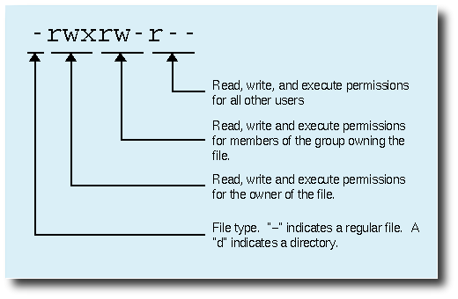

## chmod

The chmod command is used to change the permissions of a file or directory. To use it, you specify the desired permission settings and the file or files that you wish to modify. There are two ways to specify the permissions, but I am only going to teach one way.

It is easy to think of the permission settings as a series of bits (which is how the computer thinks about them). Here's how it works:

rwx rwx rwx = 111 111 111  
rw- rw- rw- = 110 110 110  
rwx --- --- = 111 000 000  
  
and so on...  
  
rwx = 111 in binary = 7  
rw- = 110 in binary = 6  
r-x = 101 in binary = 5  
r-- = 100 in binary = 4

Now, if you represent each of the three sets of permissions (owner, group, and other) as a single digit, you have a pretty convenient way of expressing the possible permissions settings. For example, if we wanted to set some_file to have read and write permission for the owner, but wanted to keep the file private from others, we would:

[me@linuxbox me]$ chmod 600 some_file

Here is a table of numbers that covers all the common settings. The ones beginning with "7" are used with programs (since they enable execution) and the rest are for other kinds of files.

|  |  |
| --- | --- |
| *Value* | *Meaning* |
| *777* | *(rwxrwxrwx)* No restrictions on permissions. Anybody may do anything. Generally not a desirable setting. |
| *755* | *(rwxr-xr-x)* The file's owner may read, write, and execute the file. All others may read and execute the file. This setting is common for programs that are used by all users. |
| *700* | *(rwx------)* The file's owner may read, write, and execute the file. Nobody else has any rights. This setting is useful for programs that only the owner may use and must be kept private from others. |
| *666* | *(rw-rw-rw-)* All users may read and write the file. |
| *644* | *(rw-r--r--)* The owner may read and write a file, while all others may only read the file. A common setting for data files that everybody may read, but only the owner may change. |
| *600* | *(rw-------)* The owner may read and write a file. All others have no rights. A common setting for data files that the owner wants to keep private. |

## Directory permissions

The chmod command can also be used to control the access permissions for directories. In most ways, the permissions scheme for directories works the same way as they do with files. However, the execution permission is used in a different way. It provides control for access to file listing and other things. Here are some useful settings for directories:

|  |  |
| --- | --- |
| *Value* | *Meaning* |
| *777* | *(rwxrwxrwx)* No restrictions on permissions. Anybody may list files, create new files in the directory and delete files in the directory. Generally not a good setting. |
| *755* | *(rwxr-xr-x)* The directory owner has full access. All others may list the directory, but cannot create files nor delete them. This setting is common for directories that you wish to share with other users. |
| *700* | *(rwx------)* The directory owner has full access. Nobody else has any rights. This setting is useful for directories that only the owner may use and must be kept private from others. |

## 

## 

## 

## Becoming the superuser for a short while

It is often useful to become the superuser to perform important system administration tasks, but as you have been warned (and not just by me!), you should not stay logged on as the superuser. In most distributions, there is a program that can give you temporary access to the superuser's privileges. This program is called su (short for substitute user) and can be used in those cases when you need to be the superuser for a small number of tasks. To become the superuser, simply type the su command. You will be prompted for the superuser's password:

[me@linuxbox me]$ su

Password:

[root@linuxbox me]#

After executing the su command, you have a new shell session as the superuser. To exit the superuser session, type exit and you will return to your previous session.

In some distributions, most notably Ubuntu, an alternate method is used. Rather than using su, these systems employ the sudo command instead. With sudo, one or more users are granted superuser privileges on an as needed basis. To execute a command as the superuser, the desired command is simply preceeded with the sudo command. After the command is entered, the user is prompted for the user's password rather than the superuser's:

[me@linuxbox me]$ **sudo some_command**

Password:

[me@linuxbox me]$

## Changing file ownership

You can change the owner of a file by using the chown command. Here's an example: Suppose I wanted to change the owner of some_file from "me" to "you". I could:

[me@linuxbox me]$ su

Password:

[root@linuxbox me]# **chown you some_file**

[root@linuxbox me]# exit

[me@linuxbox me]$

Notice that in order to change the owner of a file, you must be the superuser. To do this, our example employed the su command, then we executed chown, and finally we typed exit to return to our previous session.

chown works the same way on directories as it does on files.

## Changing group ownership

The group ownership of a file or directory may be changed with chgrp. This command is used like this:

[me@linuxbox me]$ **chgrp new_group some_file**

In the example above, we changed the group ownership of some_file from its previous group to "new_group". You must be the owner of the file or directory to perform a chgrp.

**26. Backups through rsync**

Copy/Sync a Directory on Local Computer

The following command will transfer or sync all the files of from one directory to a different directory in the same machine. Here in this example, /root/rpmpkgs contains some rpm package files and you want that directory to be copied inside /tmp/backups/ folder.

[root@tecmint]# rsync -avzh /root/rpmpkgs /tmp/backups/

sending incremental file list

rpmpkgs/

rpmpkgs/httpd-2.2.3-82.el5.centos.i386.rpm

rpmpkgs/mod_ssl-2.2.3-82.el5.centos.i386.rpm

rpmpkgs/nagios-3.5.0.tar.gz

rpmpkgs/nagios-plugins-1.4.16.tar.gz

sent 4.99M bytes received 92 bytes 3.33M bytes/sec

total size is 4.99M speedup is 1.00

**2. Copy/Sync Files and Directory to or From a Server**

Copy a Directory from Local Server to a Remote Server

This command will sync a directory from a local machine to a remote machine. For example: There is a folder in your local computer “rpmpkgs” which contains some RPM packages and you want that local directory’s content send to a remote server, you can use following command.

[root@tecmint]$ rsync -avz rpmpkgs/ root@192.168.0.101:/home/

root@192.168.0.101's password:

sending incremental file list

./

httpd-2.2.3-82.el5.centos.i386.rpm

mod_ssl-2.2.3-82.el5.centos.i386.rpm

nagios-3.5.0.tar.gz

**Copy/Sync a Remote Directory to a Local Machine**  
This command will help you sync a remote directory to a local directory. Here in this example, a directory /home/tarunika/rpmpkgs which is on a remote server is being copied in your local computer in /tmp/myrpms.  
  
[root@tecmint]# rsync -avzh root@192.168.0.100:/home/tarunika/rpmpkgs /tmp/myrpms  
root@192.168.0.100's password:  
receiving incremental file list  
created directory /tmp/myrpms  
rpmpkgs/  
rpmpkgs/httpd-2.2.3-82.el5.centos.i386.rpm  
rpmpkgs/mod_ssl-2.2.3-82.el5.centos.i386.rpm  
rpmpkgs/nagios-3.5.0.tar.gz  
rpmpkgs/nagios-plugins-1.4.16.tar.gz  
sent 91 bytes received 4.99M bytes 322.16K bytes/sec  
total size is 4.99M speedup is 1.00

**Copy a File from a Remote Server to a Local Server with SSH**

To specify a protocol with rsync you need to give “-e” option with protocol name you want to use. Here in this example, We will be using “ssh” with “-e” option and perform data transfer.

[root@tecmint]# rsync -avzhe ssh root@192.168.0.100:/root/install.log /tmp/

root@192.168.0.100's password:

receiving incremental file list

install.log

sent 30 bytes received 8.12K bytes 1.48K bytes/sec

total size is 30.74K speedup is 3.77

**Copy a File from a Local Server to a Remote Server with SSH**

[root@tecmint]# rsync -avzhe ssh backup.tar root@192.168.0.100:/backups/

root@192.168.0.100's password:

sending incremental file list

backup.tar

sent 14.71M bytes received 31 bytes 1.28M bytes/sec

total size is 16.18M speedup is 1.10

8. **Automatically Delete source Files after successful Transfer**

Now, suppose you have a main web server and a data backup server, you created a daily backup and synced it with your backup server, now you don’t want to keep that local copy of backup in your web server.

So, will you wait for transfer to complete and then delete those local backup file manually? Of Course NO. This automatic deletion can be done using ‘–remove-source-files‘ option.

**[root@tecmint]# rsync --remove-source-files -zvh backup.tar /tmp/backups/**

backup.tar

sent 14.71M bytes received 31 bytes 4.20M bytes/sec

total size is 16.18M speedup is 1.10

[root@tecmint]# ll backup.tar

ls: backup.tar: No such file or directory

### 

### 

### 

### 27. Installing Monitorix on a RHEL/CentOS/Fedora Linux

# yum install rrdtool rrdtool-perl perl-libwww-perl perl-MailTools perl-MIME-Lite perl-CGI perl-DBI perl-XML-Simple perl-Config-General perl-HTTP-Server-Simple perl-IO-Socket-SSL wget

#wget <http://www.monitorix.org/monitorix-3.8.1-1.noarch.rpm>

# rpm -ivh monitorix-3.8.1-1.noarch.rpm

# chkconfig --level 35 monitorix on  
# service monitorix start   
# systemctl start monitorix [On **RHEL**/**CentOS 7** and **Fedora 22+** versions ]

http://localhost:8080/monitorix/

SELINUX=disabled

**28. How to install Google Chrome in centos 7**

Step 1: Enable Google YUM repository

Create a file called /etc/yum.repos.d/google-chrome.repo and add the following lines of code to it.

[google-chrome]

name=google-chrome

baseurl=http://dl.google.com/linux/chrome/rpm/stable/$basearch

enabled=1

gpgcheck=1

gpgkey=https://dl-ssl.google.com/linux/linux_signing_key.pub

#yum install google-chrome-stable

**29. RDP Through Command line**

* xfreerdp -g 800x600 -u user 10.3.1.132

**30. Xfce Desktop Environment**

* **[root@dlp ~]# yum -y groups install "Server with GUI"**
* **# install from****[EPEL](https://www.server-world.info/en/note?os=CentOS_7&p=initial_conf&f=6)**
* **[root@dlp ~]# yum --enablerepo=epel -y groups install "Xfce"**

**Input a command like below after finishing installation of new packages.**

**[root@dlp ~]#** [**echo**](https://www.server-world.info/en/command/html/echo.html) **"exec /usr/bin/xfce4-session" >> ~/.xinitrc**

**[root@dlp ~]# startx**

**31. To check Display Hardware Info**

* [**yum**](https://www.server-world.info/en/command/html/yum.html) **-y install lshw**
* [**yum**](https://www.server-world.info/en/command/html/yum.html) **-y install lshw-gui**

**32. Forget root password**

**If you forgot root Password, it's possible to reset it like follows.**

**[1] Restart System and when GRUB2 boot menu is displayed, Push "e" key.**

**Next, Proceed like follows to reset root password.**

**# push "e" key  
 CentOS Linux (3.10.0-327.4.4.el7.x86_64) 7 (Core) with debugging  
 CentOS Linux (3.10.0-327.4.4.el7.x86_64) 7 (Core)  
 CentOS Linux (3.10.0-327.3.1.el7.x86_64) 7 (Core) with debugging  
 CentOS Linux (3.10.0-327.3.1.el7.x86_64) 7 (Core)  
 CentOS Linux 7 (Core), with Linux 3.10.0-229.el7.x86_64  
 CentOS Linux 7 (Core), with Linux 0-rescue-ffa496be96ad482cb94373394cec7  
  
 Use the ^ and v keys to change the selection.  
 Press 'e' to edit the selected item, or 'c' for a command prompt.  
  
setparams 'CentOS Linux (3.10.0-327.4.4.el7.x86_64) 7 (Core)' 'fedora'**

**load_video  
 set gfxpayload=keep  
 insmod gzio  
 insmod part_msdos  
 insmod xfs  
 set root='hd0,msdos1'  
 if [ x$feature_platform_search_hint = xy ]; then  
 search --no-floppy --fs-uuid --set=root --hint='hd0,msdos1' c4df086e-3699-4e02-b7cf-b47e614f6920  
 else  
 search --no-floppy --fs-uuid --set=root c4df086e-3699-4e02-b7cf-b47e614f6920  
 fi  
 # add "rw init=/bin/bash" to the end of line  
 # remove "rhgb", "quiet", "LANG=***" all if there are in this line  
 linux16 /vmlinuz-3.10.0-327.4.4.el7.x86_64 root=/dev/mapper/centos-root \  
 ro rd.lvm.lv=centos/root rd.lvm.lv=centos/swap console=ttyS0,115200n8   
 systemd.debug rw init=/bin/bash  
 initrd16 /initramfs-3.10.0-327.4.4.el7.x86_64.img  
  
 Press Ctrl-x to start, Ctrl-c for a command prompt or Escape to  
 discard edits and return to the menu. Pressing Tab lists  
 possible completions.  
  
 # after inputting above, push "Ctrl-x" key to proceed  
.....  
.....  
  
[ OK ] Stopped udev Coldplug all Devices.  
 Stopping udev Coldplug all Devices...  
[ OK ] Started Plymouth switch root service.  
[ 6.814528] systemd-journald[95]: Received SIGTERM from PID 1 (systemd).  
bash-4.2#**

**# after initramfs switch_root prompt is displayed, do like follows**

**# set SELinux relabeling on next boot if you enabling SELinux**

**bash-4.2#**

**touch /.autorelabel**

**# set password**

**bash-4.2#**

**passwd**

**Changing password for user root.**

**New password:**

**Retype new password:**

**passwd: all authentication tokens updated successfully.**

**# restart System and complete to reset**

**bash-4.2#**

**exec /sbin/init**

**33. Lynis : Security Audit Tool**

* [**yum**](https://www.server-world.info/en/command/html/yum.html) **--enablerepo=epel -y install lynis**
* **[root@dlp ~]# lynis audit system**

**34. Install Teamviewer in CentOS 7**

* **yum -y install glibc alsa-lib freetype libICE libSM libX11 libXau libXdamage libXext libXfixes libXi libXrandr libXrender libXtst libgcc libuuid libxcb zlib**
* **wget http://download.teamviewer.com/download/teamviewer.i686.rpm**
* **yum -y install teamviewer.i686.rpm**

**35. Google chrome installation in Centos 7**

* **yum update google-chrome-stable**
* **Vim /etc/yum.repos.d/google-chrome.repo**
* **Add**

**[google-chrome]  
name=google-chrome  
baseurl=http://dl.google.com/linux/chrome/rpm/stable/$basearch  
enabled=1  
gpgcheck=1  
gpgkey=https://dl-ssl.google.com/linux/linux_signing_key.pub**

* **yum info google-chrome-stable**
* **yum install google-chrome-stable**

**36.**